Business Case for Trigaware™

“A stitch in time saves nine”
Old proverb

The business case for receiving SMS or email alerts will depend upon your business. However, here are some applications. They are from real life situations and include real financial benefits.

Large and small organisations
Value for messages in large and small organisations are similar in many ways.

The main difference is that small businesses will typically gain more benefits by using the email communications “outside” to deal with clients and partners. Internal alerts typically identify and record client based activities (e.g. sales leads arriving from the web or missed service level promises).

Large organisations will identify more benefit from internal communications alerts than small organisations will. If a manager in a small organisation is behind or slightly over budget, someone can pop by and see them. In a large organisation, hundreds of employees may miss HR appraisals, expenses submissions, cost and profit targets and alerts need to flag these up. It is an accepted elementary mathematical fact that internal communications in any system rise as the system grows and as the organism becomes more complex.
The sections below cover “Large” organisations and “most” organisations.

Obviously, as some small organisations have mobile workers working in complex knowledge driven environments, the differences fade.

Alerts in large organisations
Financial Reporting: a classic application within large organisations from early report writers through to Decision support and modern business intelligence tools. It is one thing to produce outlier reports and quite another to have alerts with an audit trail warning the finance department of things going awry. Just one issue picked up and dealt with early can justify many times the price of implementing Trigaware™.
HR Reporting: Alerts can be set when the “hygene factors” are not achieved. E.g. People have not had their appraisals within a set period. There are many other important messages that can lower the costs associated with staff churn. For example alerts when a job comes up that might be suitable for an individual who has indicated that they are looking for that kind of move within the organisation.
Internal news: This is a recognised essential application in large and complex organisations. The areas include simple news from around the departments and divisions, examples of best practice that could save money or help achieve goals elsewhere and the launch of initiatives and new products and services. Most importantly, it is necessary to react to new regulatory pressures and press events quickly and effectively.
Stock/Supply: alerting suppliers to low stocks of anything from stationery to manufacturing materials or service intervals.
Internal helpdesk escalation: or IT, buildings maintenance other support functions may run an internal support function. In many instances, the implication of a delay in responding is that a service level agreement is broken which often has financial repercussions including penalties that can be claimed.

Alerts at most organisations
Customer Support Escalation: There can be no greater threat to an organisation than ignoring customer dissatisfaction. Thus the helpdesk has become more and more highly trained and measured over the years. The most important factors are now visible and one can run queries on them so that the helpdesk data can send off alerts when, for example “a grade A client has a critical level 2 problem for longer than X minutes”.
Sales leads and action tracking: is an essential function for acquiring business and managing a busy sales team. | 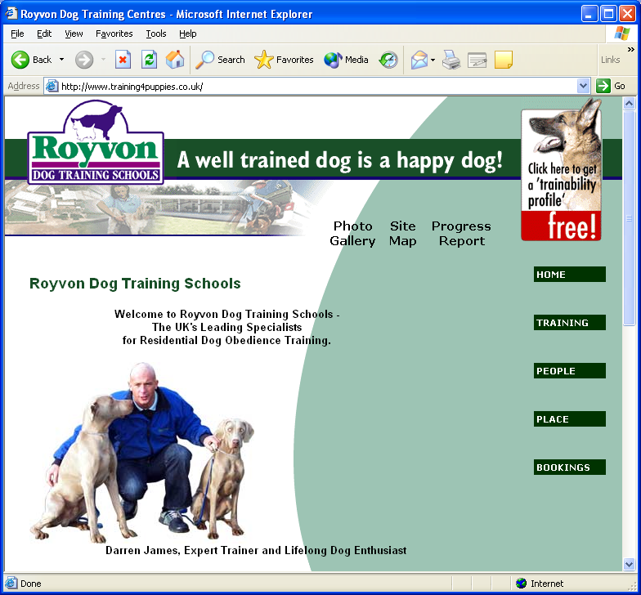
Client job sheets: when a client needs maintenance and either calls in or a job is raised as a matter of routine, Client job sheets can be raised. These can be sent out to the engineer allocated and to the client so that all are informed. This saves arguing about bills and justification for time on site later. Admin costs are reduced. Cash is collected more easily.
Warranty renewals: These are a main source of revenue for most service organisations. They can be automated early to collect cash and reduce “churn”.
Track and trace: Clients can see where their job, package, project is without having to take up administrative people’s time. | 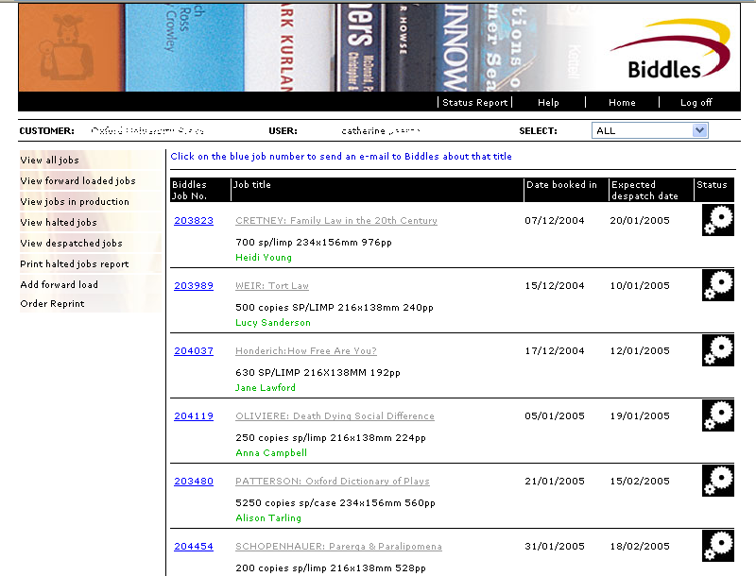
Service intervals: more service revenue at optimum frequencies that fit with your organisation’s resources. It can be generated using AXLR8 Trigaware™ for automated service renewals/intervals for maintenance.Supplier orders and client confirmations: These can be automated saving on PO and SOP production.
Project timescales slipping: Actions not recorded as having been completed

Examples from specialist markets
Leasing Contract Termination actions: The alerts system can send out emails three months before the end of a lease explaining lessees’ alternatives (e.g. return goods, carry on with the contract, acquire the product leased, etc) all of which make money for the leasing broker using AXLR8 LeaseTrack.
Mortgage Application Tracking: This allows the mortgage broker to constantly send messages to lenders, valuers, solicitors, etc. as well as to message their clients to tell them of progress.
 | This, together with AXLR8 Mortgage Track is a proven tool for winning and keeping repeat clients as well as radically reducing administration costs.
Mortgage term changes: The broker and the client should be informed three months before a mortgage changes from fixed rate to a variable rate, in order that the situation can be discussed and the client can review their mortgage arrangements. The benefits for the client can be large and the broker earns more commission for new mortgage sales.
Public authorities information requests:
The Freedom of Information Act has led to an increase in information requests. | 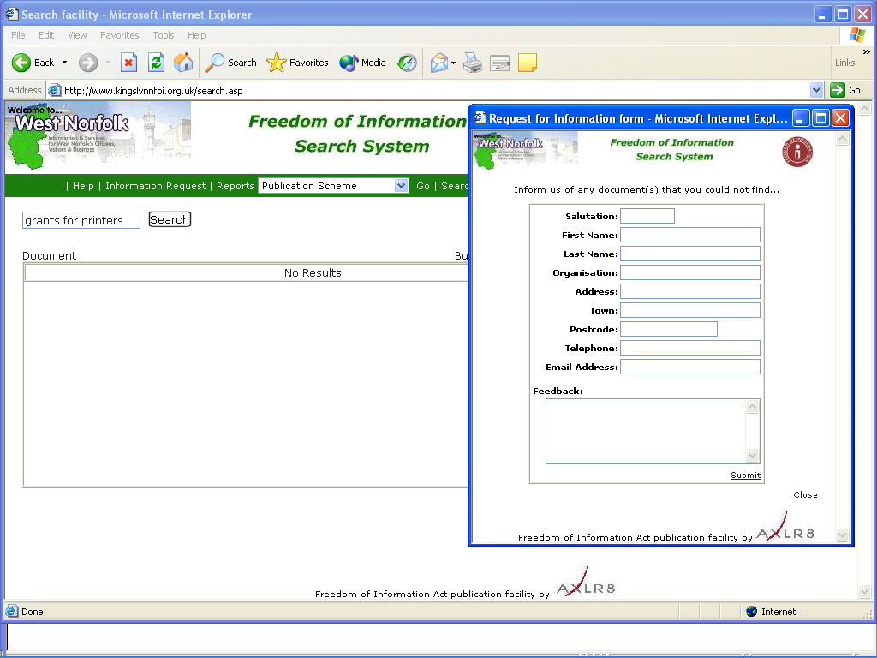
These can be costly to deal with and a single request may involve multiple departments. To help with this, the AXLR8 FOI Request Tracker system can be enhanced with Trigaware™ to allow alerts to alert and remind those departments about their actions, automatically.

How organisations use it to help achieve your goals is limited only by imagination.

