Biddles Book Printers

Business overview and aims

Biddles (www.biddles.co.uk) is a book printer established 1885 in Guildford. They use email to alert clients to problems and hold ups for action by the client inform of dispatched finished goods. With 400 clients running several hundred high complexity print runs at any one time, the sophistication of the message configurations is very high. Without an automated system to manage client relationships, the company would have to employ an impossible number of people to answer calls from clients querying details. This would raise prices but not help customer satisfaction as the information is required 24/7.

System Solution
The email alerting and reporting system is backed up by a unique “JobTracker” site with track and trace for the clients to examine production details.

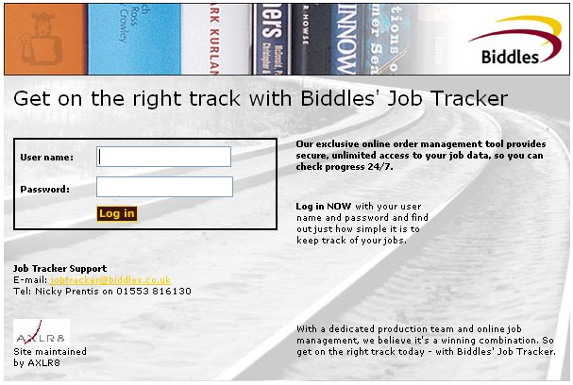
A private log in for every client contact allows people to see only their projects within their company’s printing jobs. A team leader will see all their team members print jobs.

This is linked to their legacy system that has managed their production schedules for 20 years. The information is also available for staff internally on their intranet.

Clients can also book reprints, request forward loads (reserve print run space in advance) and see breakdowns of jobs by status and project manager.

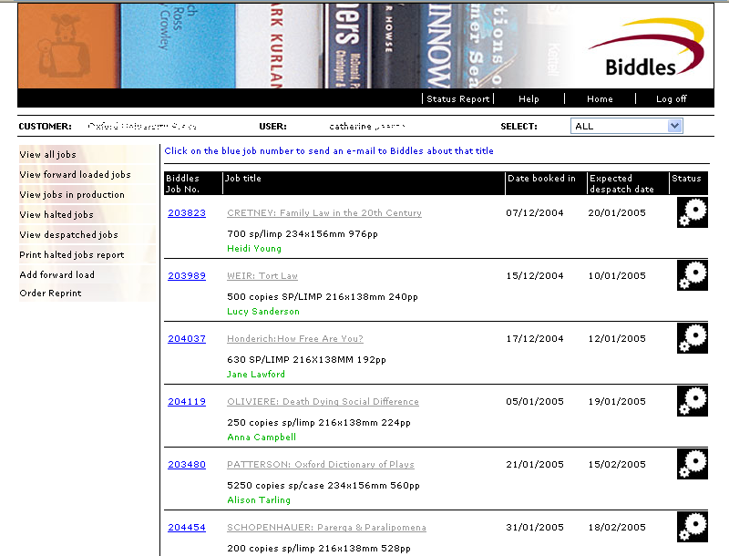
Biddles system from AXLR8 allows clients to log in and see where each of their jobs is in the manufacturing process.
To accomplish this, AXLR8’s Trigaware™ software draws data from a complex book manufacturing system running in the factory and provides each client with their data. It manages email reporting and alerts. AXLR8Synch™ manages keeps the data on the website current.

The data from a legacy production system running at their factory in Kings Lynn is synchronised using AXLR8Synch ™ with a secure web site accessible privately by individual managers at the clients. The data also

The benefits saving a massive admin overhead that would otherwise be necessary include the following.
- Provides information 24 hours, seven days a week answering customer questions.
- Saves project manager time sending proactive information and responding to repetitive questions.
- Client satisfaction, image of efficiency and accuracy hence, reducing churn with out raising costs.

Systems & Marketing Administrator, Nicky Prentis sums it up:
“It is a reliable system that has served us well over the last three years. Trigaware sends clients and our project managers the alerts that help Biddles deliver jobs on time and keep clients satisfied in an increasingly competitive market by providing excellent customer service.”

