Royvon Case study

Background and business needs
Royvon (www.royvon.co.uk) was founded nearly 50 years ago in Merthyr Tydfil, South Wales, by Roy and Yvonne James. Their son Darren and daughter Sarah have carried on the business. It is now a leading dog training company with locations expanding across the country to maximise growth in the £400m UK dog care market. To achieve their growth plans and their customer satisfaction goals, they need multiple accurately personalised communications with their clients every day. To manage the data, Royvon have implemented a system based upon AXLR8FastTrack™ CRM with an extranet and intranet and communications facilities. The industry leading “PetAdmin™” application from Woodhouse Technology is the main back office kennelling system which is totally integrated with the AXLR8 customer facing systems. Royvon was advised by Venture Wales. All this has been achieved on an SME budget.

Their prospects are drawn into the website by many mechanisms including an innovative trainability survey. Details are synched with AXLR8 FastTrack™ CRM which forms the core marketing system. From there, AXLR8 Trigaware looks at profiles and sends out SMS, letters and emails in response, according to people’s media preferences. Media preference is also held in AXLR8FastTrack™ CRM. Later when the prospects book on a course, AXLR8 Synch™ sends the data to the sophisticated PetAdmin system which handles all kennelling, dietary, health and some aspects of billing.

AXLR8 Trigaware™ sends progress reports to owners. The progress is also presented on a private webpage on the Royvon extranet shown below. Quality Control feedback mechanisms and all the automated features add an unrivalled professional depth to a genuine personal touch. After all, everyone who works at Royvon is devoted to dogs!

On filling out the Trainability Survey, owners get a response based upon the facts they put in about their dog or dogs. The response is totally auto-personalised and full of experience acquired over many decades. | 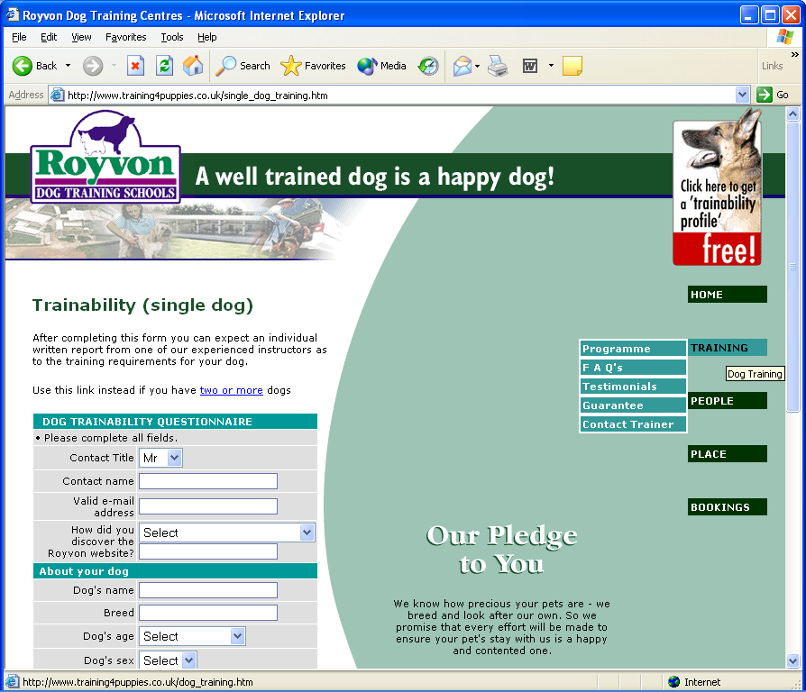

The site is well promoted on the web by specialist e-marketer Business for Business and many visitors fill out the on-line Trainability Survey prominently promoted on the top right hand corner of the site. These, and others who are perhaps recommended by previous clients, book online or by telephoning. Once booked on the course, around two dozen messages are sent out providing logistics and progress information to keep the owners up to date.

“What has my dog learned in school today?”  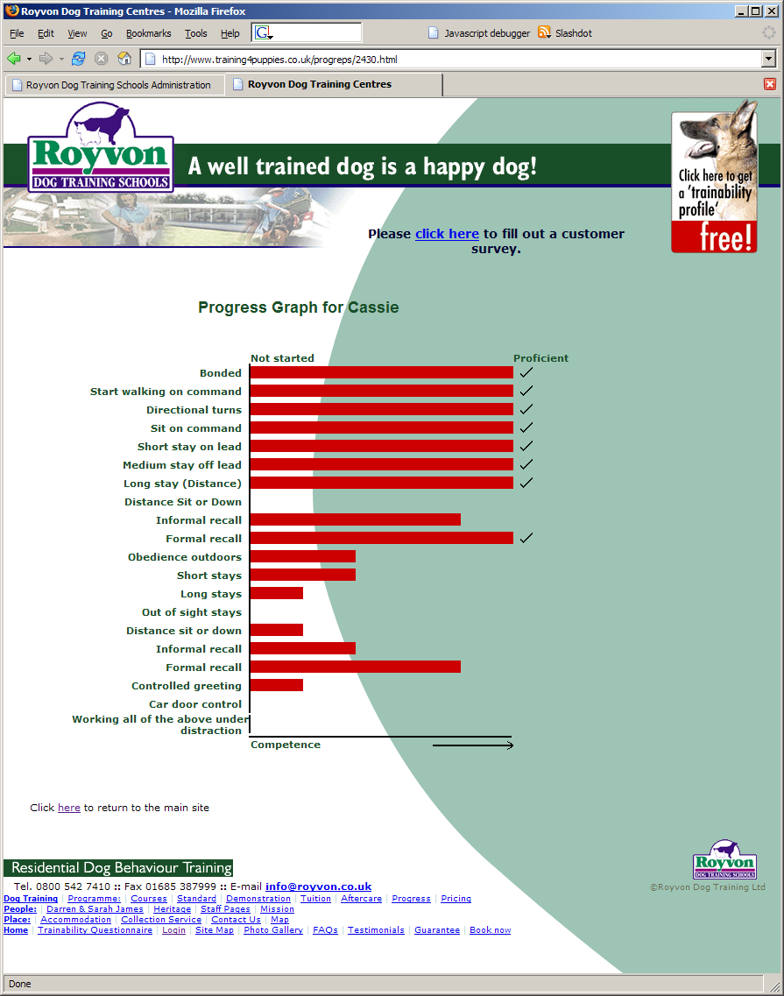 | Progress of the dogs as they learn new skills is presented on a constantly updated website.  On the day of departure, the owners attend a half day course with their dogs to understand how to maintain and build upon, the improved behaviour.  Client feedback is constantly sought on the site through online forms and is stored in FastTrack.  Additional functionality planned in the next few months includes webcam viewing of dogs on the website and an RFID based tracking system to measure the time dogs spend exercising and training.

Progress reports are sent as emails, SMS or letter according to the media preferences of the client. The purpose of these messages ranges from making sure the dog is inoculated 7 days before arrival, introducing the personal trainer, progress information and course information for the last day. Many dozen dogs in the programmes on any day may be of either sex and may be with another dog from the same family. Therefore, the syntax has to deal with decisions like “his” or “her” or “their”. Progress details are drawn from many internal systems. In particular, a training intranet built by AXLR8 allows supervisors to assign handlers to each dog.

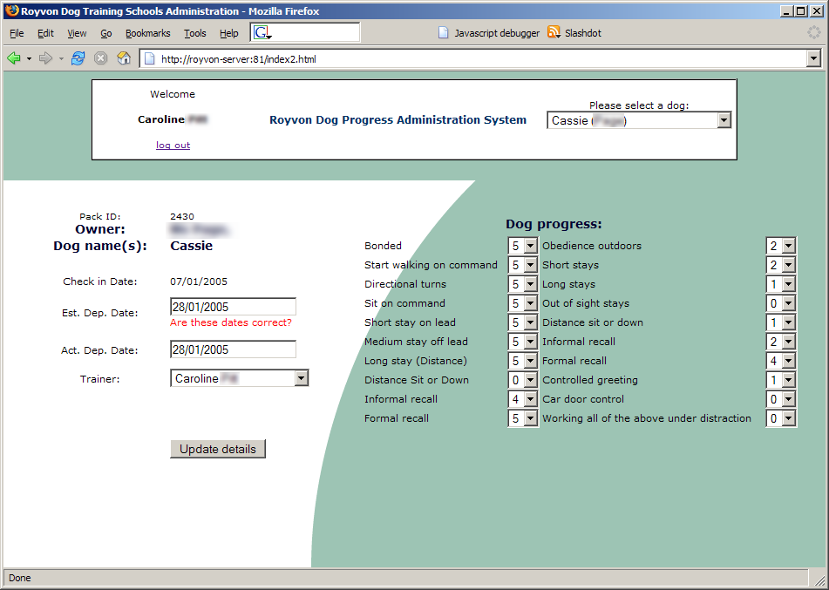
The trainers record the dog’s progress regularly throughout the day on this screen. The data is then available for the system to use for sending news to owners or, indeed, for other colleagues in the office who can answer owners’ calls when the assigned trainer is out with the dog.

If you are an experienced direct marketing professional, you will have realised that this is a hairy marketing situation. It involves high data complexity and runs in real time. You may be asking a few questions! Here are some we have been asked.
- How, with virtually no administration and definitely no IT staff available, do you manage the errors which occur in several dozen letters/emails an hour which will rise to hundreds per hour? (The number of messages rises logarithmically with new courses and new branches.)
- How do the progress reports deal with the sex and number of dogs, and the name of the actual human trainer so that it sounds as if a human had “just dropped you a note to say how your dog or dogs was/were getting along”? (It is difficult enough to put the last sentence together!)
- Is it really all automatic or do you employ an army of typists doing data entry? (Yes it is automatic even when BT drops the line, the system just waits till it can carry on again from where it left off.)
- Did it cost the equivalent of the GDP of a small country to implement?
- Could Royvon help my dog who chases children in Regents Park?

The answers are all contained in the bullet proof modular design of AXLR8’s Trigaware™ which is described below.

About AXLR8Trigaware™
The AXLR8 Trigaware™ product provides the direct marketing communications professional with a number of tools such as template builders and ways of describing trigger events. For example, a template for a mailshot can be created that is triggered to go when people enquiring from the website have not booked after three weeks.

For this to work, you obviously need a data file (with the contacts who will receive the mailshot) and a document and possibly some boilerplates just like a Microsoft Word mail merge. However, because of the complexity of multiple components in a message and multiple preferences and profiles, Trigaware™ uses the following two components which form a part of the AXLR8 Marcom Manager’s WorkBench.

- Data about contacts comes from AXLR8 FastTrack™ at Royvon but could be in any other third party systems.
- The Templates and boilerplates are stored in Trigaware™ Template Manager.

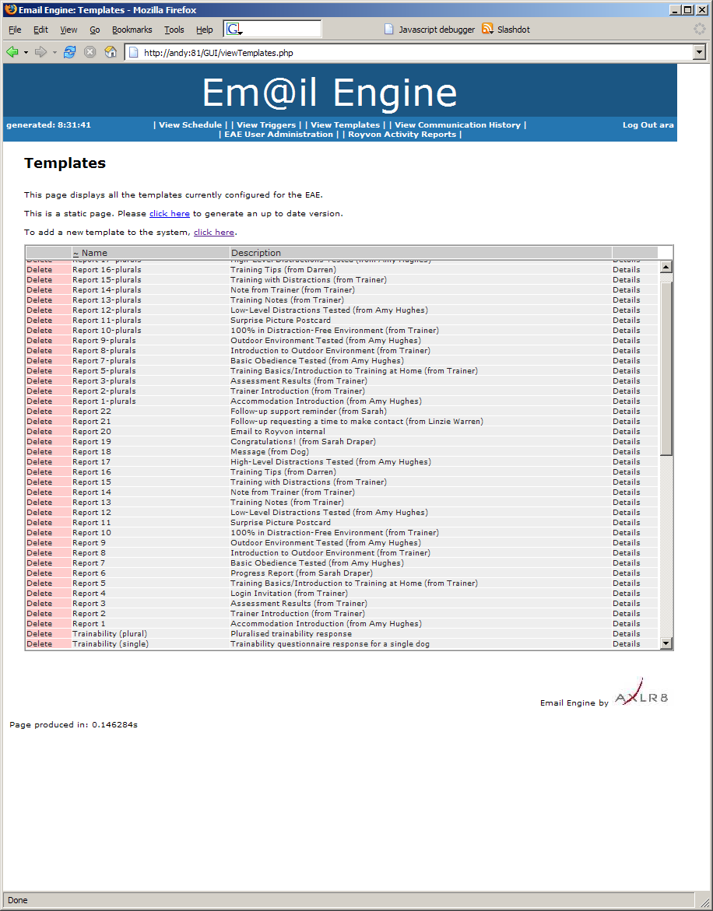 | 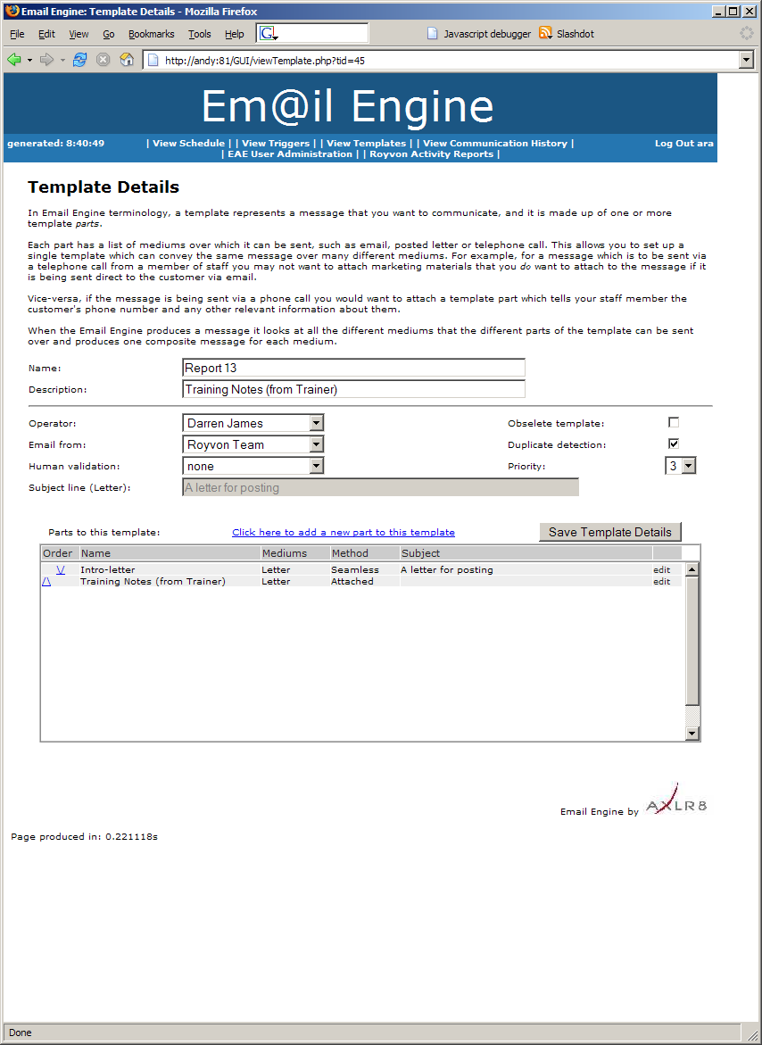
Templates are built and named for reference. These details are available later when errors need to be traced in communications logs
So far it is just like any mailshot. Creation of emails is then managed through the Template Manager user interface. Then it gets rather more complex. The next tools help with the more difficult parts of the problem.

- The event Trigger Monitor is responsible for deciding when to send mails ( e.g. “every week on Friday afternoon”, “as soon as this dog has reached level 5 on exercise 2”). These can be absolute or conditional events.
- The Validator decides whether the messages pass the rules for eventual transmission (“Is the email valid?”, “Was an identical message sent to that person just before the power cut?”).
- The Message Quality Workbench provides many at a glance views of data and message quality with drill down links to see more detail of messages that have failed.

Without these tools and subsystems, the task would be so complex. One would give up before one started. Tracing errors would be like following spaghetti round a plate of bolognaise. This is because there are many areas where a small data quality issue may invalidate, say, one or many dozen emails – seemingly at random.

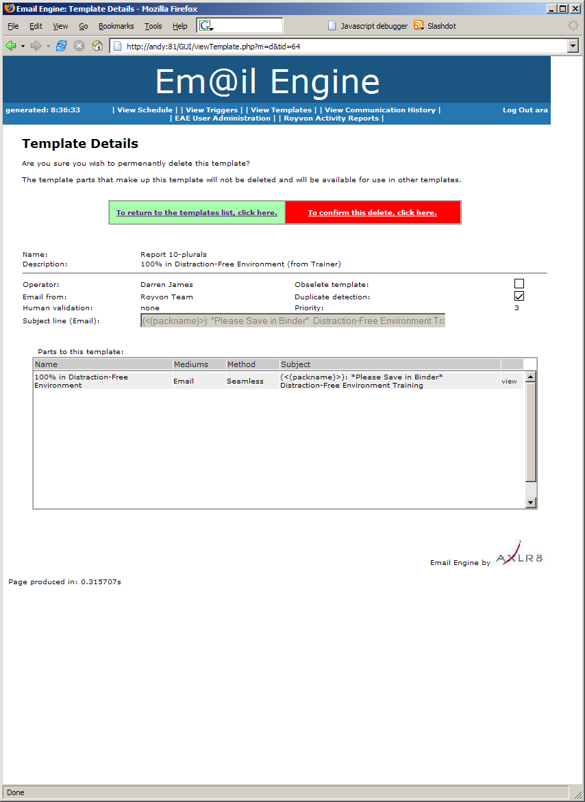

Indeed the rule based “Validator” will not let many emails through if they have been flagged up as incomplete, duplicated or just plain daft. Therefore, a very sophisticated quality assurance system is used as well as a suite of management and monitoring tools. Some of these are described below together with screens showing the management reporting user interface.

A complete communications history is stored for the record.  The data is hashed to allow efficient storage and fast searching.  The purpose of keeping the communications varies from client to client: de-duplication against future emails, re transmission in case of occasional requests for copies by recipients, for compliance in some industries and for many other reasons. | 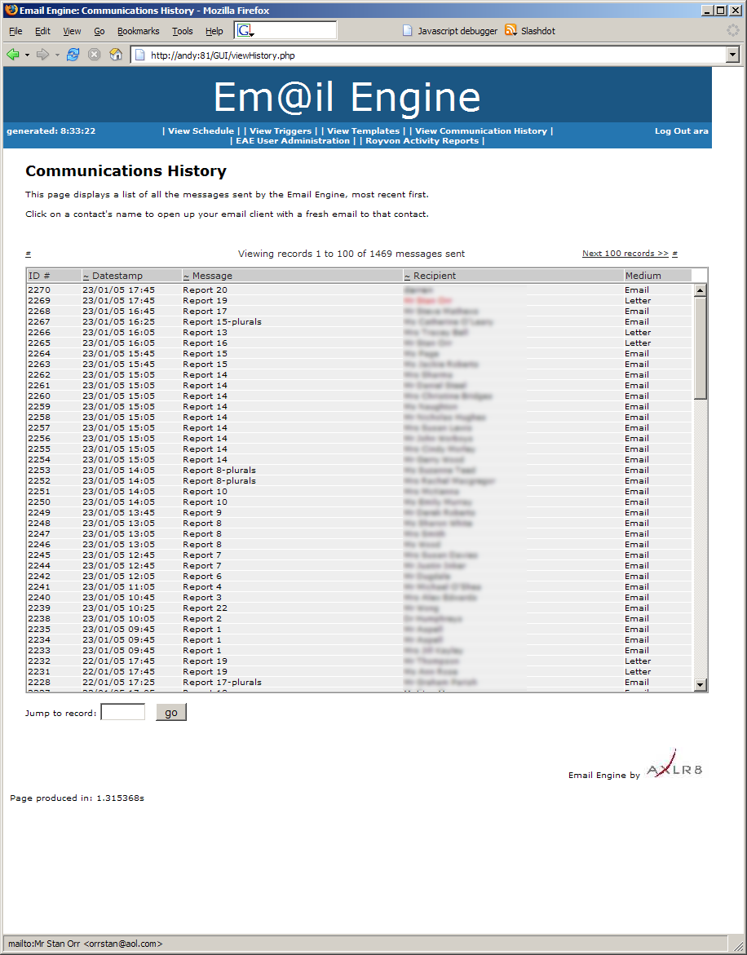

The communications history is stored in the system efficiently and there are methods for vary fast retrieval of a client’s communications trail in any medium. The system is also fully integrated with the AXLR8 document management facilities though Royvon has not needed to implement this facility.
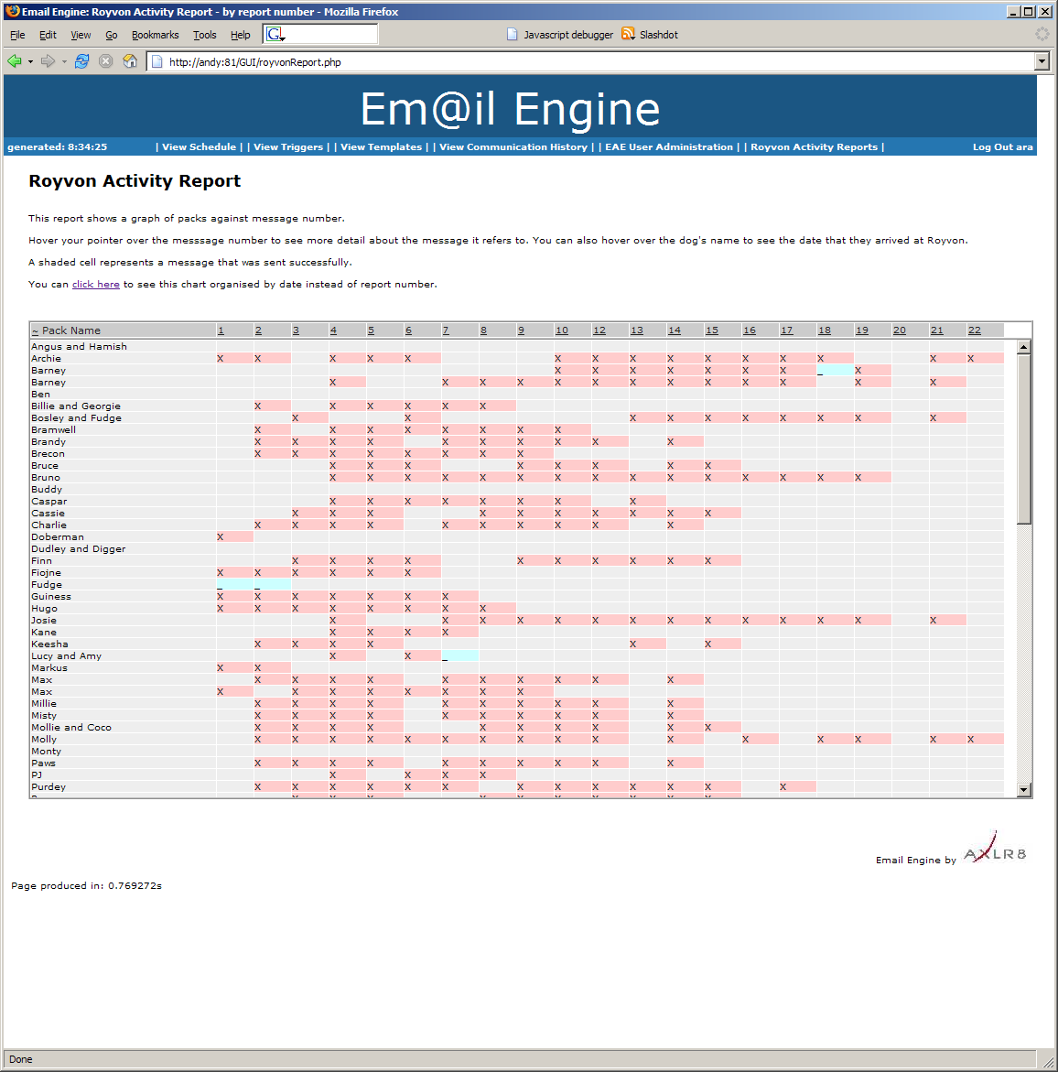
At a glance views allow the message queues and histories to be analysed and summarised. Different symbols and shades/colours show pending, sent, stopped, failed and other status transmissions.

The graphical pictures can be sorted by message reference or by date to make it easy to spot geometric patterns caused by specific problems.

Often these problems in your marketing profiles or message campaign plans are impossible to spot without these presentations.

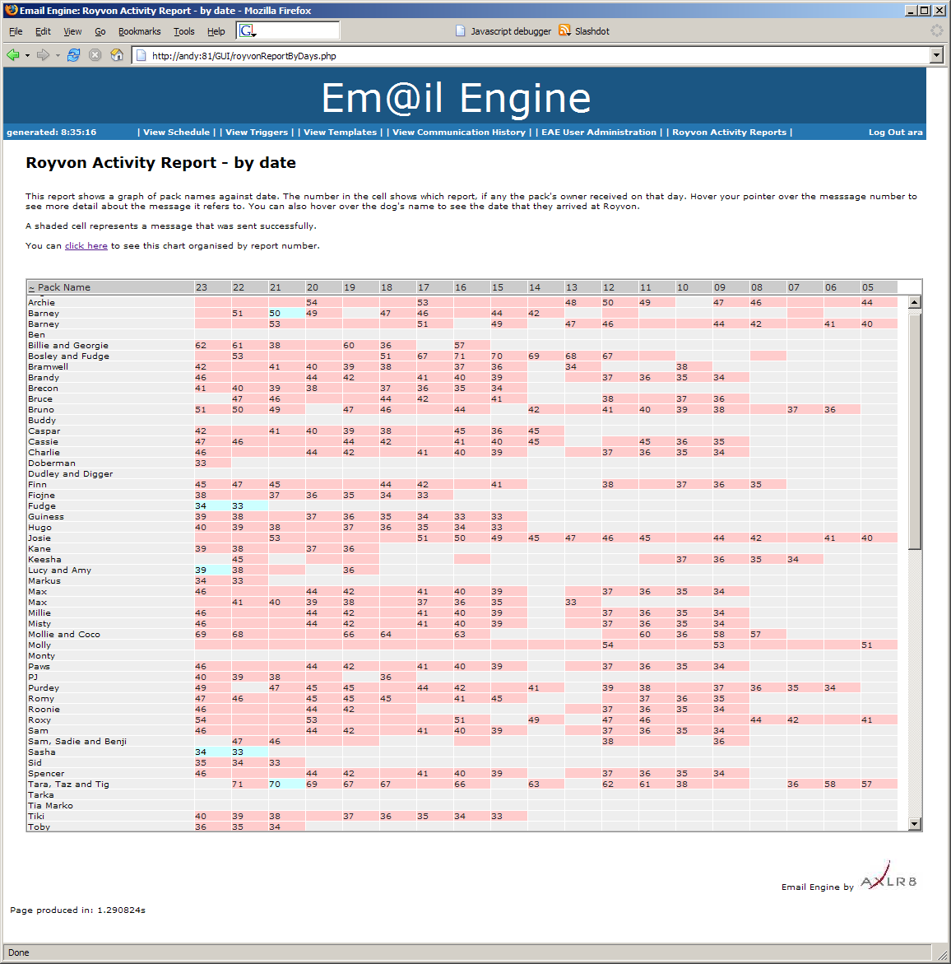

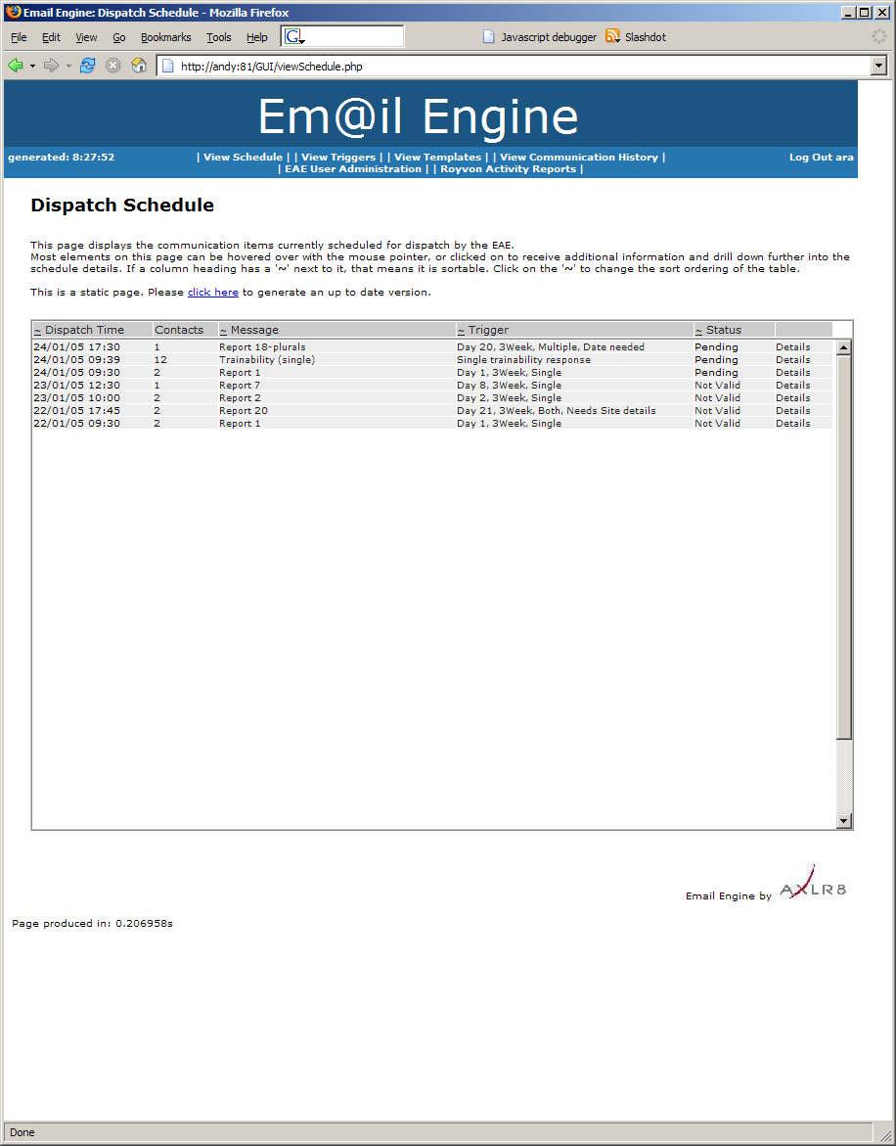

Lastly, the above screen demonstrates the ability to do predictive quality control on future communications. The individual items can be clicked upon to view further details of templates, conditions that trigger the dispatch contacts, to whom it will go, and the other properties of the item selected.

So far, the system has attracted few complaints from the dogs!

